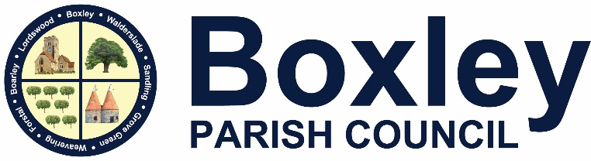

Beechen Hall, Wildfell Close, Walderslade, Chatham, Kent ME5 9RU.

🕿 01634 861237

🖂 clerk@boxleyparishcouncil.org.uk

**Clerk**: Daniela Baylis

**Assistant Clerk**: Heidi Pearson

**Finance**: Nichola Carter

[www.boxleyparishcouncil.org.uk](http://www.boxleyparishcouncil.org.uk)

**A G E N D A**

**To All Members of the Council, Press and Public**

**All Members of the Council, Press and Public there will be an Extraordinary Estates Committee Meeting to be held on Tuesday 22 October 2024 at 11.00 am at Beechen Hall, Walderslade, ME5 9RU.**

1. **Apologies and absences**

To receive and accept apologies for absences.

1. **Declaration of Interests, Dispensations, Predetermination or Lobbying**

Members are required to declare any interests, dispensations, predetermination or lobbying on items on this agenda. Members are reminded that changes to the Register of Interests should be notified to Maidstone Borough Council.

1. **Allotment Road**

To look at the allotment road quotations.

1. **Container Base Quotations**
2. **CCTV/ANPR Cameras**

Daniela Baylis

Daniela Baylis

Clerk to the Council. Date: 7 October 2024